# Section 6 Lesson 6 Exercise 1: Retrieving Data Using SELECT

**Write and Execute SELECT statements (S6L6 Objective 2)**

In this exercise you will retrieve data that is stored in the database system by using a SELECT statement.

PART 1

**Part 1: Retrieving all columns from a table.**

Using the SELECT * statement show all data stored in the following tables:

1. customers.

1. teams.

1. items

**Part 2: Selecting Specific Columns**

1. Display the customer number, first name, last name, email and phone number of the customers.

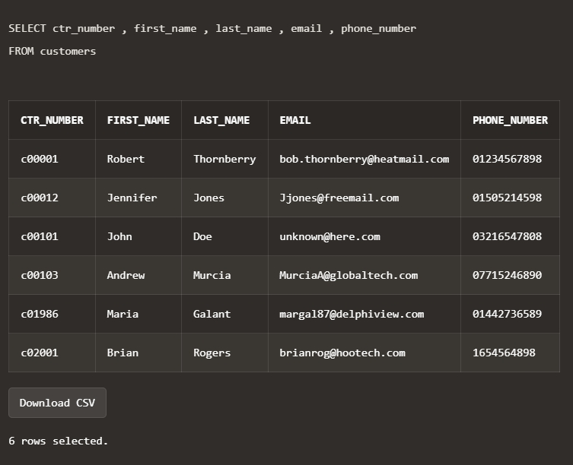

1. Display the name and number of players for each team.

1. Display the name, description and category for every item in the table.

**Write and Execute SELECT statements (S6L6 Objective 2)**

In this exercise you will retrieve data that is stored in the database system by using a SELECT statement.

## PART 2

1. Every customer has been told they can pay off their current balance over a 12 month period. Display the customer’s first name, last name, current balance and monthly payment.

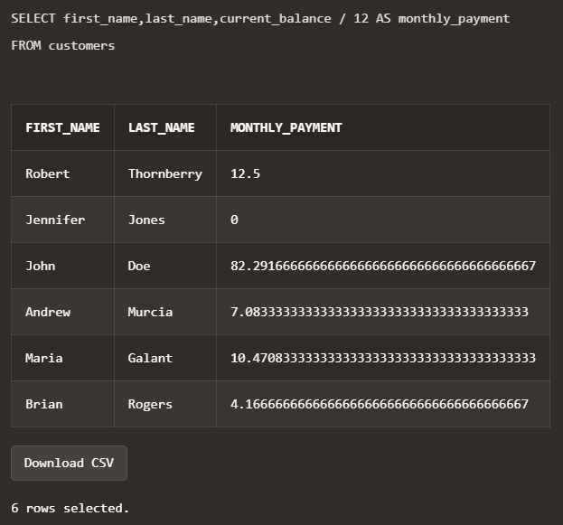

1. Obl is considering giving a gift card to all its customers of 5.00 that can be used to reduce their current balance. Write a query that will show the customers first name, last name, customer number, current balance and the value of their balance minus the gift value.

1. What would be the problem with implementing this scheme?

**The potential problem with this scheme is that it assumes a fixed monthly payment or a designated gift card value for all customers. Customers may have different financial situations, and a one-size-fits-all approach may not be suitable. Some customers may find the fixed monthly payment too high, while others may benefit little from a selected gift card value**.

## PART 3

**Part 1: Using the WHERE Clause.**

1. Using the unique customer number in the where clause display all columns for Maria Galant.

1. Display the first name, last name and customer number for all customers who have a current balance of greater than 100. Use an appropriate alias for your column headings.

1. Display the order id, date and time of all orders that were placed before the 28th of May 2019. Use an appropriate alias for your column headings.

## Part 2: Range Conditions: BETWEEN Operator

1. Display the inventory id, cost and number of units using appropriate aliases for all items that have a trade cost of between 3.00 and 15.00.

## Part 3: Membership Conditions: IN Operator

1. Display the inventory id, cost and number of units using appropriate aliases for all items that have 50, 100, 150 or 200 units in stock.

## Part 4: Membership Conditions: NOT IN Operator

1. Display the inventory id, cost and number of units using appropriate aliases for all items that do not have 50, 100, 150 or 200 units in stock.

## Part 5: Pattern Matching: LIKE Operator

1. Display item number and name of all items that have a name that begins with g. Use an appropriate alias for your column headings.

## Part 6 : Pattern Matching: Combining Wildcard Characters with the LIKE Operator

1. Display item number and name of all items that have a name that contain a lowercase o. Use an appropriate alias for your column headings.

## PART 4

## Part 1: Using the NULL Conditions

1. Write a query that will display information for teams that don’t receive a discount in the following format:

The Rovers team has 8 players and does not receive a discount.

Use **Team Information** as the column alias.

1. Write a query that will display information for only teams that receive a discount in the following format:

The Rockets team has 25 players and receives a discount of 10 percent.

Use **Team Information** as the column alias.

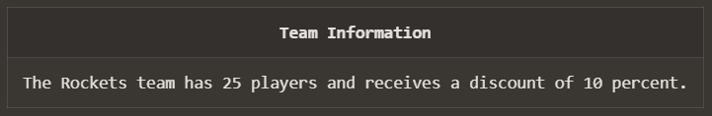

## Part 2: Logical Operators: AND

1. Write a query that will display the customer number, address line 1 and postal code for customers that live in the starford area of Liverpool. Use Customer Number, Street Address and Postal Code as the column aliases.

## Part 3: Logical Operators: OR

1. Write a query that will display the customer number, address line 1 and postal code for customers that live in either starford or Liverpool in general. Use Customer Number, Street Address and Postal Code as the column aliases.

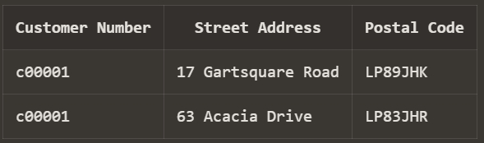

## Part 4: Logical Operators: NOT Equal To

1. Write a query that will display the customer number, address line 1 and postal code for customers that do not live in Liverpool. Use Customer Number, Street Address and Postal Code as the column aliases.

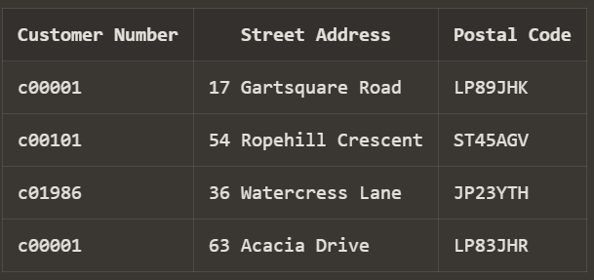

## PART 5

**Use the ORDER BY Clause to Sort SQL Results (S6L8 Objective 1)**

In this exercise you will sort the order of the data that is returned in your query by adding an ORDER BY clause to the end of your SELECT statement.

1. Display the team name and number of players alphabetically in order of team name. Use an appropriate alias for your column headings.

1. Display the team name and number of players in descending order of number of players. Use an appropriate alias for your column headings.

1. Display the team name and number of players alphabetically in order of team name. Use Team Name for the name alias and Players for the number of players. Sort the output in descending order of name using the alias in the ORDER BY clause.

## PART 6

1. The customers are numbered sequentially with each new customer being assigned a higher customer number. Use TOP-N-ANALYSIS to only show the First and last name of the first three customers. Show the customers first and last name in the same column using Customer Name as the column alias.

## Part 2 : Using a Substitution Variable (S6L8 Objective 4)

1. Use a substitution variable that will allow you to enter the commission rate for the sales representatives. The first and last names should be displayed to screen for any sales representatives that earn that commission rate and the output should be ordered by their last name. Use an appropriate alias for your column headings.

## 

## 

## 